Comparative Analysis of Machine Learning Models for Housing Price Index Prediction
Jonathan Jose Penaloza Rumie
Advisor- Dr. Sayani Sarkar
Computer Science Department
04/29/2025

Table of Contents
- Introduction
- Background
- Methodology
3.1. Dataset Acquisition and Description
3.2. Data Preprocessing and Regional Classification
3.3. Data Cleaning and Filtering
3.4. Feature Scaling and Normalization
3.5. Exploratory Data Analysis
3.6. Machine Learning Models
- Experiments and Results
  - Hyperparameters of Machine Learning Models
  - Evaluation Metrics
  - Results
- Conclusion
- Future Scope
- References

List of Figures
- Figure 1: Regional Housing Price Trends Over Time
- Figure 2: Distribution of Housing Price Indices by Region
- Figure 3: Pairwise Relationships and Regional Patterns
- Figure 4: Correlation Matrix
- Figure 5: Distributional Analysis - Violin Plot
- Figure 6: Distributional Analysis - Box Plot
- Figure 7: Distributions by HPI Type and Region
- Figure 8: Time Series Decomposition
- Figure 9: Regional Housing Price Index Trends Over Time
- Figure 10: Regional Housing Price Index Trends Over Time
- Figure 11: Feature Importance and Selection for LightGBM
List of Tables
- Table I: Hyperparameter Tuning for LightGBM
- Table II:

1. Introduction
The housing market's dynamic nature and its critical role in the economy make accurate price prediction a complex yet essential task. As the real estate landscape evolves, influenced by factors ranging from property characteristics to broader economic trends, the need for sophisticated analytical tools becomes increasingly apparent. This capstone project addresses this challenge by developing a comprehensive House Pricing Pattern Analysis model, leveraging advanced data science and machine learning techniques.
Much like how social media platforms grapple with evolving spam tactics, the housing market faces its own set of challenges in identifying and interpreting pricing patterns. Traditional methods of house price estimation often struggle to capture the nuanced interplay of factors that influence property values. These can include subtle neighborhood changes, shifting buyer preferences, or even the impact of global events on local markets. Our approach aims to uncover these hidden patterns and relationships, providing insights that go beyond surface-level analysis.
The project utilizes a diverse dataset encompassing various property features, location data, and economic indicators. By employing a range of machine learning models, including Linear Regression, Random Forests, Gradient Boosting, and Support Vector Machines, we aim to capture both linear and non-linear relationships within the data. This multi-model approach allows us to address the complexities of the housing market, much like how diverse algorithms are used to combat evolving spam techniques in social media.
Our analysis will focus on identifying key drivers of housing prices, examining how different features interact, and assessing the robustness of our models against market fluctuations. This approach not only aims to produce accurate price predictions but also to provide valuable insights into market trends and potential future directions.
The implications of this work extend beyond mere price prediction. By developing a deeper understanding of housing market dynamics, this project contributes to more informed decision-making for buyers, sellers, and policymakers alike. Just as advanced spam detection systems aim to create safer digital environments, our House Pricing Pattern Analysis seeks to foster a more transparent and efficient real estate market.
Through this capstone project, we aim to demonstrate the power of data-driven approaches in deciphering complex market behaviors, ultimately contributing to a more stable and equitable housing sector.
2. Background
The paper "What Drives House Price Cycles? International Experience and Policy Issues" by John V. Duca, John Muellbauer, and Anthony Murphy provides an extensive analysis of the factors influencing house price cycles across different countries. The authors explore the historical and contemporary drivers of housing prices, emphasizing the role of real estate during the global financial and economic crisis. They highlight the need to incorporate housing and financial channels into macroeconomic models to better understand these dynamics.
The paper categorizes the key factors affecting house price cycles into several areas: credit markets, house price expectations, financial stability, and the wider economy. It discusses how these factors interact and influence housing markets, with a particular focus on the diversity in international and regional behavior of house prices. The authors review both theoretical and empirical studies, providing a comprehensive overview of the literature on housing markets and their connection to economic activity.
The survey underscores the importance of improving data tracking for key housing supply and demand influences. It also examines how monetary, macroprudential, and other policies affect house prices and access to housing. The paper highlights the ongoing challenges in understanding house price dynamics and the need for continuous research to address these issues.
Overall, the paper serves as a valuable resource for policymakers and researchers interested in financial stability and the role of housing in the broader economy. It provides detailed insights into the current state of knowledge on house price cycles and offers directions for future research [1].
The paper "Housing Price Prediction Based on Multiple Linear Regression" by Qingqi Zhang provides an in-depth analysis of using multiple linear regression (MLR) to predict housing prices. The study focuses on identifying the significant factors influencing housing prices and developing a predictive model based on these factors. The author first analyzes the major factors affecting housing prices using the Spearman correlation coefficient to select the most significant variables.
The paper categorizes the key factors influencing housing prices in several areas, including location, surroundings, area, and facilities. By applying the MLR model to a dataset of real estate prices in Boston, the study demonstrates that the model can effectively predict housing prices to a certain extent. The author highlights that while the MLR model provides valuable insights, there is potential for improvement through the integration of more advanced machine learning methods.
The paper serves as a valuable resource for researchers and practitioners in the field of real estate economics. It provides a detailed overview of the current state of housing price prediction using multiple linear regression and offers insights into potential future developments. The study emphasizes the importance of accurate housing price prediction for various stakeholders, including households, investors, and policymakers [2].
The paper "A Survey of Methods and Input Data Types for House Price Prediction" by Margot Geerts and Jochen De Weerdt provides a comprehensive overview of the various techniques and data types used in house price prediction. The authors conduct a systematic literature review, identifying 93 articles published between 1992 and 2021 that present different methods for predicting house prices. This review aims to provide insights into the data types and modeling approaches utilized in the current body of research.
The paper categorizes the key methods and input data types into several areas, including conventional methods, advanced techniques, and innovative data sources. Conventional methods and traditional input data remain predominant in-house price prediction research. However, the study highlights a gradual shift towards more advanced techniques and innovative data sources, such as unstructured data and complex spatial data. The authors emphasize the potential of deep learning and tailored methods to improve the accuracy of house price predictions.
The survey underscores the importance of accurate house price prediction for various stakeholders, including buyers, sellers, notaries, banks, and policymakers. It discusses how improved prediction models can enhance real estate appraisal and housing policies. The paper also identifies opportunities for future research, particularly in incorporating more advanced input data types and adopting cutting-edge machine learning techniques.
Overall, the paper serves as a valuable resource for researchers and practitioners in the field of real estate economics. It provides a detailed overview of the current state of house price prediction methods and offers insights into potential future developments. The study emphasizes the need for continuous improvement in prediction techniques to better inform parties in the real estate market and improve the accuracy of valuations [3].
The paper "The Role of U.S. Real Estate as an Inflation Hedge" by Ana Rita de Sousa Mateus Filipe examines the effectiveness of the U.S. real estate sector in mitigating inflation. The study spans 25 years, from 1998 to 2023, utilizing both quarterly and yearly data to capture short-term fluctuations and long-term trends in the real estate market.
The author employs various methodologies, including Ordinary Least Squares (OLS) regression, cointegration tests, and Granger causality tests, to analyze the relationship between real estate returns and inflation. The study uses three indices as proxies for real estate returns: the NCREIF Property Index (FNRE Index), the FTSE NAREIT Equity REIT Index (NPNCRE), and the Dow Jones U.S. Selected REIT Index (DWRTF).
The paper incorporates key macroeconomic variables that influence real estate returns, such as stock market real returns, U.S. GDP growth rate, money supply, and interest rates. The Consumer Price Index (CPI) is used as a proxy for inflation, specifically the CPI Urban Consumer Less Food & Energy YoY NSA, which focuses on core inflation.
The research aims to address the gap in existing literature by focusing on the U.S. market and providing new insights into whether U.S. real estate returns offer genuine protection against inflation. The study's findings challenge existing assumptions by revealing varying effectiveness across different segments of real estate in protecting against inflation.
Overall, this paper contributes to the ongoing debate about the role of real estate as an inflation hedge and provides valuable insights for investors, policymakers, and researchers interested in the relationship between real estate and inflation in the U.S. market [4].
The paper "Housing Price Prediction via Improved Machine Learning Techniques" by Truong, Nguyen, Dang, and Mei investigates the application of machine learning to improve housing price prediction, addressing the limitations of relying solely on House Price Indices (HPI) and the lack of comprehensive model comparisons in previous studies. The authors highlight the need for additional information, such as location, area, and population, to predict individual housing prices effectively.
The study acknowledges the growing trend of using machine learning for housing price prediction due to its ability to accurately predict prices based on various attributes. However, it notes that many existing studies fail to consider the combination of different machine learning models to enhance prediction accuracy.
To address these gaps, the paper adopts a Stacked Generalization approach, an ensemble technique, to optimize predicted values. The authors utilize the "Housing Price in Beijing" dataset from Kaggle, consisting of over 300,000 data points with 26 variables representing housing prices traded between 2009 and 2018. They apply several preprocessing and feature engineering steps to cleanse the dataset and extract meaningful features.
The paper emphasizes the importance of exploratory data analysis to discover implicit patterns in the data, which helps in selecting appropriate machine learning approaches. It provides visualizations illustrating the relationships between location, age, price, building type, and other features.
The selected machine learning models include Random Forest, among others, and the evaluation metric used is the Root Mean Squared Logarithmic Error (RMSLE). The authors aim to validate the performance of each individual approach and demonstrate the potential of machine learning, particularly the Stacked Generalization method, for achieving improved and more accurate housing price predictions [5].
3. Methodology
This section outlines a comprehensive and structured methodology for analyzing housing price indices across different geographic regions of the United States. The focus is placed on preparing robust, region-categorized data that enables temporal and spatial analysis of housing market trends. This methodology details the processes of dataset acquisition, geographic categorization, data cleaning, and normalization. The approach aims to create a standardized analytical framework that provides insights into regional housing market dynamics while maintaining statistical validity and interpretability.
This research adopts a rigorous data processing framework to investigate how housing prices vary across different regions and time periods. The methodology is carefully designed to reflect the complex nature of the U.S. housing market, including the geographic diversity and economic distinctions between different regions. By incorporating regional classifications and maintaining controlled preprocessing conditions, the study ensures a fair and meaningful comparison of housing indices across both spatial and temporal dimensions. This approach allows for a thorough exploration of regional housing market trends, thereby informing more robust economic analysis and policy formulation.
3.1. Dataset Acquisition and Description
The foundation of this study is built upon the House Price Index (HPI) dataset obtained from the Federal Housing Finance Agency (FHFA), accessed through their official government website [6]. The HPI dataset is a comprehensive collection of housing price information that tracks changes in single-family home values across various geographic levels in the United States. The dataset includes temporal variables (year and period), geographic identifiers (place_id and place_name), and index values that reflect housing price fluctuations.
The initial dataset encompasses multiple geographic levels, from national (USA) to Census Divisions and individual states. It also contains different HPI types (traditional) and flavors (purchase-only), with data collected at monthly frequency. The housing price indices are represented in both seasonally adjusted (index_sa) and non-seasonally adjusted (index_nsa) formats, providing flexibility for various types of analysis.
3.2. Data Preprocessing and Regional Classification
To enhance the analytical value of the dataset and facilitate meaningful regional comparisons, several preprocessing steps were implemented. First, the seasonally adjusted index column (index_sa) was removed to focus the analysis on the non-seasonally adjusted values, which better reflect raw market movements. This decision was based on the study's emphasis on understanding actual market fluctuations rather than adjusted trends.
A critical enhancement to the dataset was the introduction of a regional classification system. The United States was divided into five distinct regions based on geographic and economic similarities: Northeastern, Southeastern, Southwestern, Midwestern, and Western. This classification was implemented through a mapping system that assigned each state and Census Division to its corresponding region using standard geographic conventions:
- Northeastern: ME, NH, VT, MA, RI, CT, NY, NJ, PA
- Southeastern: DE, MD, DC, VA, WV, NC, SC, GA, FL, AL, MS, TN, KY, PR
- Southwestern: AR, LA, OK, TX, NM
- Midwestern: ND, SD, NE, KS, MO, IA, MN, WI, IL, IN, MI, OH
- Western: WA, OR, CA, ID, NV, MT, WY, UT, CO, AZ
Additionally, Census Divisions were mapped to their corresponding regions to ensure comprehensive coverage of all geographic entities in the dataset. This regional classification provides a more nuanced framework for analyzing housing market trends beyond individual state boundaries, allowing for the identification of broader regional patterns and divergences.
3.3. Data Cleaning and Filtering
To focus the analysis on meaningful geographic units and improve data quality, extensive filtering was performed. Metropolitan Statistical Areas (MSAs), represented by numeric place_id values, were removed from the dataset. This decision was motivated by the desire to concentrate on state-level and regional analyses, which offer more generalized insights into housing market dynamics. The filtering process eliminated over 350 MSA-level entries, resulting in a dataset that primarily contains state and Census Division data points.
Data integrity was ensured through the identification and removal of missing values. The examination revealed a single null value in the index_nsa column, which was subsequently dropped to maintain data completeness. This minimal data loss (one observation) had a negligible impact on the overall analysis while ensuring that all remaining data points were valid and complete.
3.4. Feature Scaling and Normalization
The final preprocessing step involved the normalization of the housing price index values. A MinMaxScaler from the scikit-learn library was applied to transform the index_nsa column to a standardized range between 0 and 1. This normalization technique preserves the relative relationships between index values while making them more comparable across different regions and time periods.
The normalization process is particularly important for subsequent analyses, as it facilitates direct comparisons of housing price trends across regions with significantly different baseline values. It also prepares the data for potential machine learning applications, where feature scaling is often a prerequisite for optimal model performance.
The resulting dataset represents a clean, structured, and regionally classified housing price index that is well-suited for temporal and spatial analysis of housing market trends across the United States. This comprehensive preprocessing approach ensures that the data is optimally prepared for exploratory analysis, visualization, and potential predictive modeling in subsequent research stages.
3.5. Exploratory Data Analysis
This section presents a thorough exploratory analysis of the normalized House Price Index (HPI) dataset, with a focus on regional trends, distributional characteristics, and inter-variable relationships. The visualizations provide critical insights into the temporal and geographic dynamics of the U.S. housing market, highlighting both long-term growth patterns and regional disparities. Historical events and economic cycles are also reflected in the observed trends, offering context for the patterns revealed in the data.

Figure 1. Regional Housing Price Trends Over Time
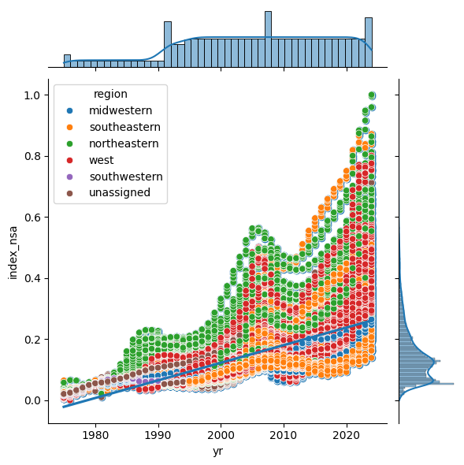
The first figure presents a scatter plot of the normalized housing price index (index_nsa) over the years (yr), with points colored by region. The marginal histograms show the distribution of years and index values. This visualization reveals a consistent upward trend in housing prices across all regions from the late 1970s through 2025. Notably, the Northeastern (green) and Western (red) regions exhibit higher index values compared to the Midwestern (blue) and Southeastern (orange) regions, indicating stronger appreciation in these areas. The plot also captures significant historical events: the housing bubble and subsequent crash around 2008 is visible as a plateau or dip in price growth, followed by a recovery phase. The sharp increase in index values post-2020 aligns with the COVID-19 pandemic housing boom, driven by low interest rates and increased demand. The presence of unassigned and southwestern regions is minimal, indicating effective regional classification. The overall pattern underscores regional disparities in housing market dynamics and the impact of macroeconomic events on price trajectories.
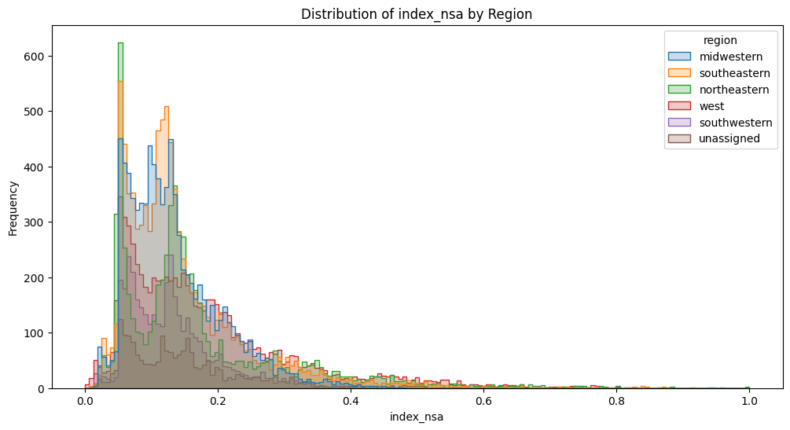
Figure 2: Distribution of Housing Price Indices by Region
The second figure shows overlaid histograms of the normalized HPI distributions segmented by region. All regions display right-skewed distributions, with most index values concentrated at lower levels, reflecting the long-term baseline prices. The Northeastern and Western regions have a higher frequency of elevated index values, reinforcing their status as high-growth markets. Conversely, the Midwestern and Southeastern regions show more concentration at lower index values, indicative of more moderate price appreciation. The spread and shape of these distributions suggest greater market volatility and price escalation in coastal and urbanized regions, consistent with historical migration patterns, economic development, and supply-demand imbalances. This distributional insight complements the temporal trends observed in the previous figure, providing a holistic view of regional housing market behavior.
Figure 3: Pairwise Relationships and Regional Patterns
The third figure is a pairplot matrix illustrating relationships among index_nsa, yr, and period (month), colored by region. The strong positive relationship between the year and housing price index is evident across all regions, reaffirming persistent price growth over time. The period variable, representing months, shows cyclical patterns but lacks strong correlation with price indices, indicating minor seasonal effects compared to dominant long-term trends. Regional clustering is apparent, with Northeastern and Western regions consistently exhibiting higher index values. The uniform distribution of data points across months and years suggests comprehensive temporal coverage, supporting robust trend analysis. This multidimensional view highlights the interplay between temporal factors and regional market characteristics, essential for nuanced economic interpretation.
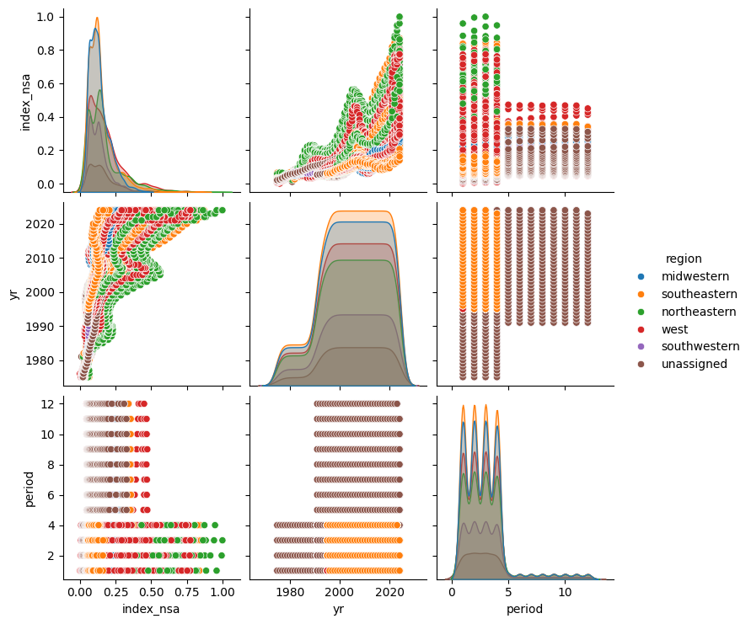
Figure 4: Correlation Matrix
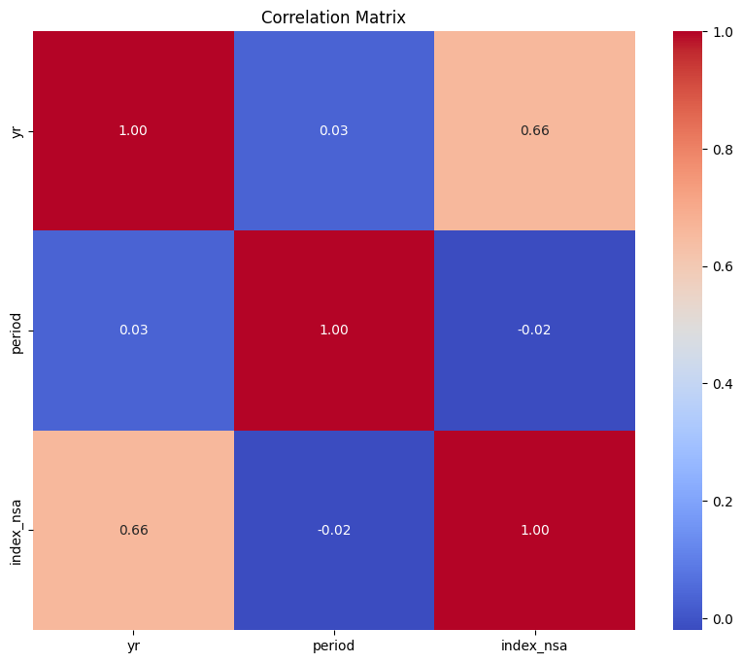
The fourth figure displays a correlation heatmap among the key numerical variables: year (yr), month (period), and normalized housing price index (index_nsa). A strong positive correlation (0.66) between the year and housing price index quantitatively confirms the observed upward trend in housing prices over time. The near-zero correlation between month and both year and index indicates that seasonal variations have a minimal impact on long-term price trends. This independence supports the focus on annual and regional dynamics without significant confounding from monthly fluctuations. The correlation matrix thus validates the temporal patterns and justifies the emphasis on year-over-year analysis in understanding housing market behavior.
Figure 5: Distributional Analysis - Violin Plot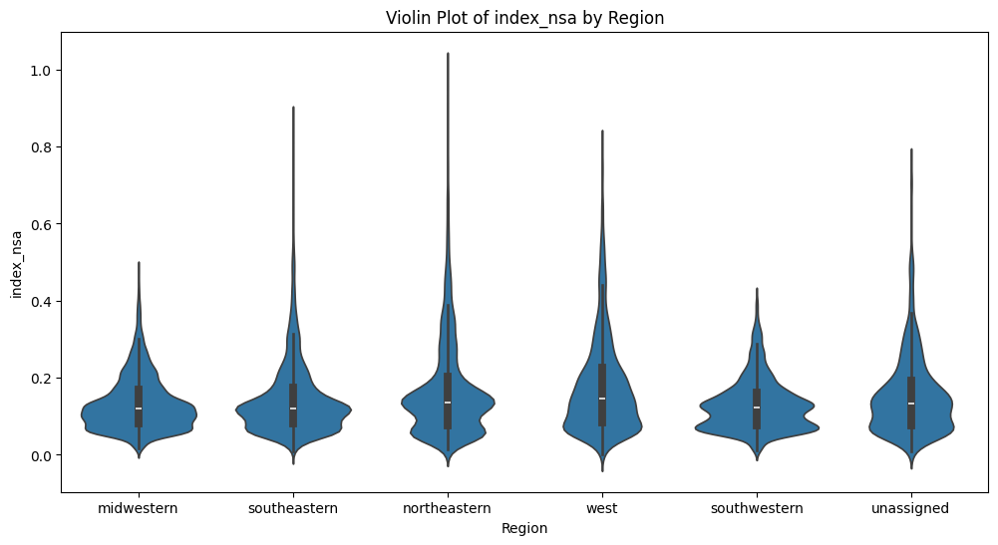
Figure 6: Distributional Analysis - Box Plot
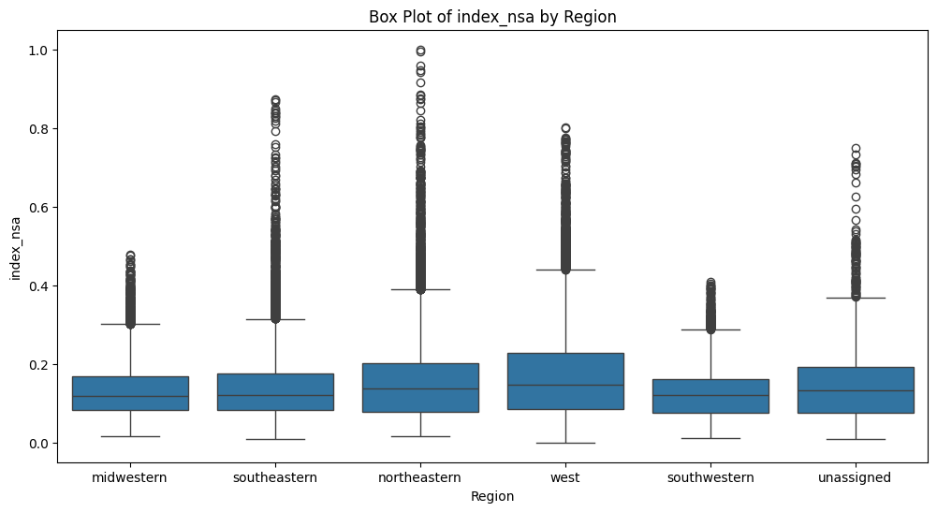
The violin plot of normalized housing price index (index_nsa) by region offers a detailed view of the distributional shape and spread within each geographic area. Each violin’s width represents the density of data points at different index values. Across all regions, the distributions are right-skewed, with most values concentrated at the lower end, but with long tails extending toward higher values. The Northeastern and Western regions display slightly higher medians and broader upper tails, indicating not only more frequent high-price observations but also greater variability and the presence of extreme values. The Southeastern and Midwestern regions, in contrast, show narrower distributions with lower medians, reflecting more stable and modest price growth. The southwestern and unassigned regions follow similar patterns but with fewer data points.
Complementing the violin plot, the box plot of index_nsa by region succinctly summarizes central tendency and dispersion. The median index is highest in the Northeastern and Western regions, with interquartile ranges also wider, confirming greater price volatility. Outliers are more numerous and extreme in these regions, further underscoring the impact of speculative booms, urban demand, and economic shocks. The Midwestern and Southeastern regions again show tighter clustering, consistent with their historical reputation for affordability and slower, steadier price appreciation.
Figure 7: Distributions by HPI Type and Region
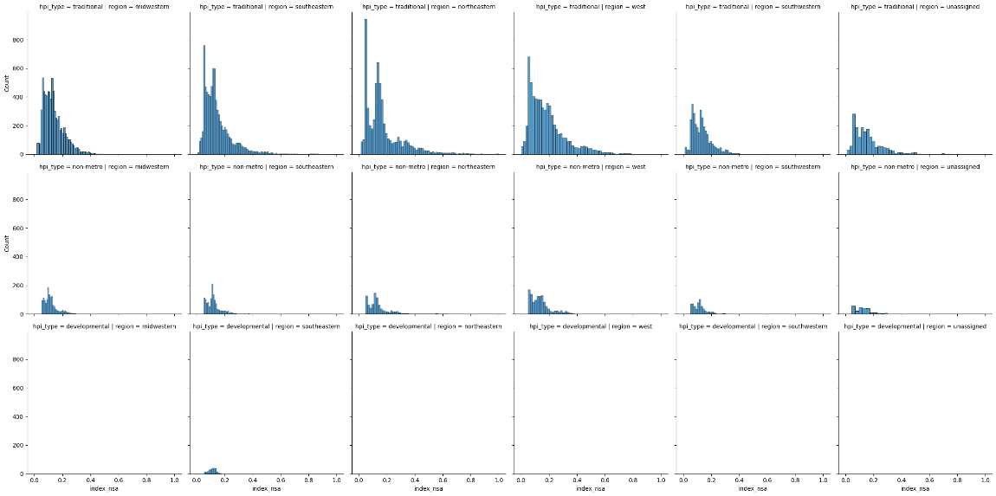
The grid of histograms breaks down the distribution of index_nsa by both HPI type (traditional, non-metro, and developmental) and region. Traditional indices dominate the dataset and display the widest spread, especially in the Northeastern and Western regions, where high-value outliers are more common. Non-metro indices, representing rural or less urbanized areas, are heavily concentrated at lower index values across all regions-reflecting the more gradual and stable growth typical of these markets. Developmental indices, which are sparse, cluster tightly at the lowest end, indicating that new or emerging markets have yet to experience significant price appreciation.
These patterns highlight the importance of both geography and market maturity in shaping housing price dynamics. Urbanized, economically vibrant regions (Northeast, West) and established markets (traditional HPI) are more susceptible to volatility, while rural and developmental areas remain more insulated from rapid swings.
Figure 8: Time Series Decomposition
The time series decomposition plot for index_nsa reveals the underlying components driving housing price changes.
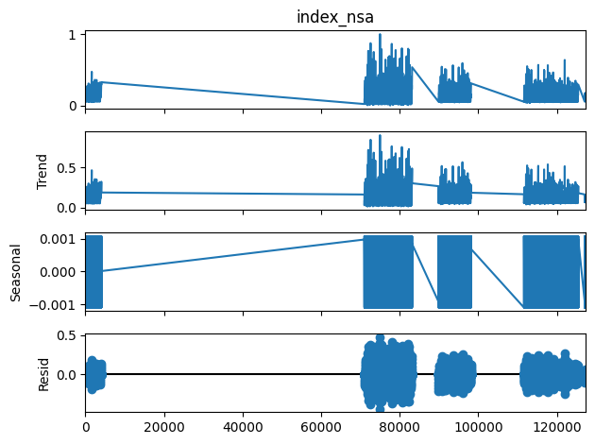
The "Trend" component shows long-term upward movement, punctuated by periods of stagnation or decline, likely corresponding to economic recessions or housing market corrections. The "Seasonal" component is nearly flat, confirming that seasonal effects are minimal in the aggregated dataset. The "Residual" component captures irregular short-term fluctuations, which become more pronounced in recent years-potentially reflecting increased market volatility, speculative activity, or data reporting changes.
This decomposition supports the earlier finding that long-term economic cycles, rather than short-term seasonality, are the primary drivers of U.S. housing price trends.
Figure 9: Regional Housing Price Index Trends Over Time
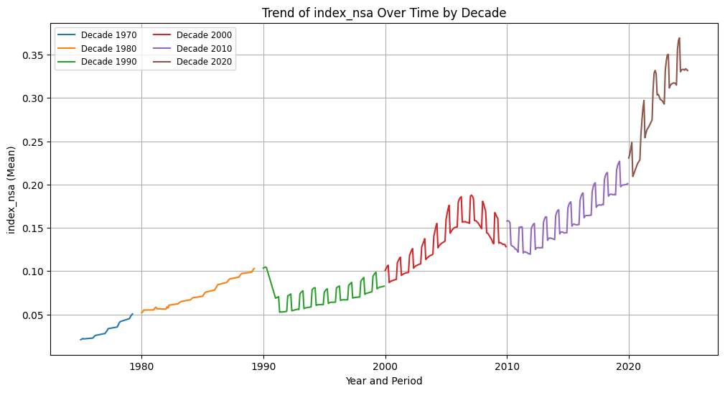
Figure 9 provides a decade-by-decade breakdown of the mean normalized housing price index over time. Each decade is color-coded, allowing for a clear comparison of growth patterns across different economic eras. The 1970s and 1980s (blue and orange) are characterized by gradual, steady increases, reflecting the post-industrial expansion and relatively stable economic conditions. The 1990s (green) show a slight dip at the start, possibly linked to the early 1990s recession, but then resume a moderate upward trajectory. The 2000s (red) are marked by a rapid escalation in prices, peaking around 2007, which aligns with the housing bubble fueled by easy credit and speculative investment. This is followed by a sharp drop and stagnation, capturing the impact of the Great Recession. The 2010s (purple) depict a period of recovery and renewed growth, while the 2020s (brown) stand out for their unprecedented surge in housing prices, reflecting the unique economic and social dynamics of the COVID-19 era, such as remote work, supply chain disruptions, and aggressive monetary policy. The cyclical, sawtooth pattern within each decade reflects seasonal fluctuations, but the dominant trend is one of long-term appreciation punctuated by major economic events.
Figure 10: Regional Housing Price Index Trends Over Time
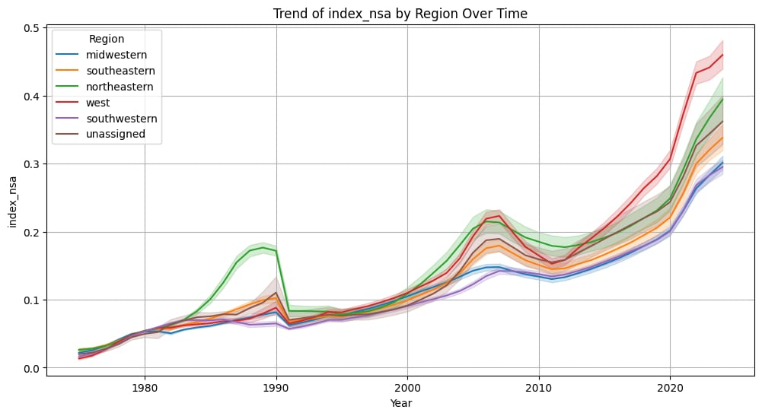
Figure 10 presents a line plot that tracks the normalized housing price index (index_nsa) by region from the mid-1970s to the mid-2020s. Each region is represented by a distinct color, with shaded confidence intervals indicating variability. This visualization reveals several important features of the U.S. housing market’s evolution. All regions display a persistent upward trend in housing prices, but the rate and magnitude of growth vary significantly. The Western region (red) exhibits the most dramatic increase, particularly in the last decade, outpacing all other regions and reflecting the extraordinary appreciation seen in states like California, Colorado, and Washington. The Northeastern region (green) also demonstrates robust growth, especially during the late 1980s and early 2000s, periods historically associated with economic booms and urban expansion in cities such as New York and Boston. In contrast, the Midwestern (blue) and Southeastern (orange) regions show more moderate, steady growth, consistent with their reputation for affordability and stability. Notably, all regions experienced a pronounced dip or stagnation around 2008, coinciding with the global financial crisis and the collapse of the U.S. housing bubble. The subsequent recovery is evident, with a particularly sharp acceleration post-2020, likely driven by historically low interest rates, pandemic-related migration, and heightened demand for housing. The inclusion of southwestern and unassigned categories, though less prominent, highlights the comprehensive nature of the dataset and ensures that regional nuances are captured.
Together, these visualizations capture the evolution of the U.S. housing market over nearly five decades, reflecting key economic cycles and regional disparities. The gradual price appreciation from the 1970s through the 1990s aligns with post-industrial economic growth and suburban expansion. The rapid escalation and subsequent crash around 2008 correspond to the well-documented housing bubble and financial crisis, which disproportionately affected certain regions. The recovery and acceleration in the 2010s, culminating in the recent surge during the COVID-19 pandemic, highlight the influence of monetary policy, demographic shifts, and changing housing demand. Regional differences observed in the data reflect economic diversity, population movement, and local market conditions, emphasizing the importance of geographic granularity in housing market analysis.
In summary, the exploratory data analysis effectively reveals long-term growth trends, regional heterogeneity, and the imprint of historical economic events on U.S. housing prices. These insights provide a solid foundation for further modeling and policy-oriented research.
3.6 Machine Learning Models
To evaluate the predictive performance on the housing price index dataset, a diverse set of machine learning regression models was implemented. These models span simple linear regressors, ensemble methods, and state-of-the-art gradient boosting frameworks, providing a comprehensive exploration of modeling strategies suitable for continuous target prediction.
Linear Regression serves as the foundational model, establishing a baseline by fitting a linear relationship between input features and the housing price index. While straightforward and interpretable, it assumes linearity and may struggle to capture complex, nonlinear patterns present in the housing market data.
Ridge, Lasso, and ElasticNet regression extend linear regression by incorporating regularization terms to prevent overfitting. Ridge applies L2 regularization, shrinking coefficients toward zero, which is effective when many features contribute moderately. Lasso uses L1 regularization, promoting sparsity by driving some coefficients exactly to zero, aiding feature selection. ElasticNet combines both L1 and L2 penalties, balancing sparsity and coefficient shrinkage, which is useful when features are correlated.
Support Vector Regression (SVR) leverages the principles of Support Vector Machines for regression tasks. By using kernel functions such as the radial basis function (RBF), SVR can model nonlinear relationships by mapping input features into higher-dimensional spaces. This makes SVR well-suited for capturing complex dependencies in housing prices, though it can be computationally intensive on large datasets.
K-Nearest Neighbors Regression (KNN) predicts target values based on the average of the nearest neighbors in feature space. Its non-parametric nature allows it to model arbitrary functions without assuming a specific form. However, KNN’s performance can degrade with high-dimensional data or noisy features, and it may be computationally expensive for large datasets.
Random Forest Regressor is an ensemble of decision trees trained on bootstrap samples with random feature subsets. This bagging approach reduces variance and improves generalization, making it robust to noise and capable of modeling nonlinear relationships. Its interpretability is moderate, with feature importance metrics aiding understanding.
Gradient Boosting Regressor builds an additive model in a forward stage-wise fashion, sequentially fitting new learners to the residuals of previous models. This approach excels in capturing complex patterns and interactions, often outperforming other models when properly tuned. However, it requires careful hyperparameter optimization to avoid overfitting and ensure convergence.
XGBoost and LightGBM represent advanced gradient boosting implementations optimized for speed and scalability. They incorporate techniques such as tree pruning, histogram-based splitting, and parallel processing, enabling efficient training on large datasets. Both frameworks support regularization and early stopping, enhancing model robustness.
These models were selected to offer a balanced perspective on regression strategies, from interpretable linear models to powerful ensemble learners. The training process involved standard preprocessing steps such as feature scaling and encoding, followed by hyperparameter tuning using grid search and cross-validation to optimize model performance. Evaluation metrics including mean squared error (MSE) and R-squared (R²) were used to compare models fairly.
This diverse modeling approach ensures a thorough assessment of the housing price index prediction task, enabling identification of the most effective algorithms for capturing the underlying economic and regional dynamics reflected in the data.
4. Experiments and Results
This section presents the experimental setup, hyperparameter tuning, model evaluation metrics, and results obtained from applying various machine learning regression models to predict the housing price index. The analysis includes a detailed examination of LightGBM’s feature importance, highlighting its role in model interpretability and performance.
4.1 Hyperparameters of Machine Learning Models
A grid search was conducted to optimize the hyperparameters of the Light Gradient Boosting Machine (LightGBM) model. The tuning process explored a range of values for learning rate, number of estimators, number of leaves, maximum tree depth, and minimum child samples to identify the best configuration for minimizing prediction error. The hyperparameters and their tested values are summarized below:
Table I: Hyperparameters of Machine Learning Models
The following table summarizes the key hyperparameters used or tuned for each model during the experiments:
Model | Key Hyperparameters | Notes
Linear Regression | Default parameters | Baseline linear model without regularization
Ridge Regression | Default alpha | L2 regularization applied
Lasso Regression | Alpha tuned via GridSearchCV: [0.001, 0.01, 0.1, 1, 10] | L1 regularization with hyperparameter tuning
Elastic Net | Default parameters | Combination of L1 and L2 regularization
Support Vector Regression (SVR) | Default kernel (RBF), default C and epsilon values | No explicit hyperparameter tuning performed
K-Nearest Neighbors (KNN) | n_neighbors=5, Minkowski distance metric (p=2) | Fixed number of neighbors
Random Forest | n_estimators=900, max_depth=20, min_samples_split=10, bootstrap=True, random_state=42 | Tuned for depth and number of trees
Gradient Boosting | n_estimators=100, random_state=42 | Default learning rate and depth
XGBoost | learning_rate=0.1, n_estimators=200, min_child_weight=2, subsample=1, colsample_bytree=0.8, reg_lambda=0.45, reg_alpha=0, gamma=0.5, random_state=42 | Tuned for regularization and tree parameters
LightGBM | Tuned via GridSearchCV: learning_rate=0.2, n_estimators=200, num_leaves=100, max_depth=-1, min_child_samples=20 | Best parameters found through hyperparameter tuning
The best parameters indicate a model configuration that balances complexity and generalization, allowing the LightGBM model to capture intricate patterns in the data without overfitting.
4.2 Evaluation Metrics
The models were evaluated using two primary metrics:
- Mean Squared Error (MSE):
MSE measures the average squared difference between predicted and actual housing price index values. Lower MSE values indicate better predictive accuracy and less deviation from true values. In the context of housing price prediction, a low MSE reflects the model’s ability to closely estimate market trends and price fluctuations.
- R-squared (R²):
R² represents the proportion of variance in the target variable explained by the model. Values closer to 1 indicate that the model accounts for most of the variability in housing prices. An R² near zero or negative suggests poor predictive power. For housing market analysis, a high R² confirms that the model effectively captures underlying economic and regional influences on prices.
These metrics together provide a comprehensive assessment of model performance, balancing error magnitude and explanatory capability.
Figure 11: Feature Importance and Selection for LightGBM
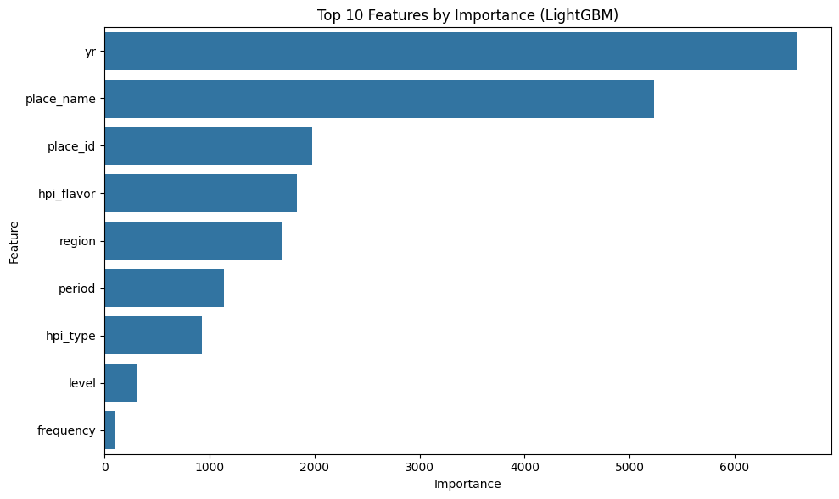
Figure 11 illustrates the top 10 features ranked by their importance in the LightGBM model for predicting the housing price index. The most influential feature by a substantial margin is the year (yr), which underscores the dominant role of long-term temporal trends in shaping housing prices across the dataset. This strong importance reflects how housing prices have steadily increased over time, capturing the effect of economic cycles, inflation, and market growth.
The second most important feature is place_name, which represents the specific geographic location, such as a state or census division. This highlights the significant impact of local market conditions and regional economic factors on housing price dynamics. Closely following are place_id and hpi_flavor. The place_id feature further refines geographic granularity, allowing the model to distinguish between different localities, while hpi_flavor captures methodological variations in how the housing price index is calculated, indicating that the way the index is constructed also affects predictive accuracy.
Other notable features include region, which aggregates broader geographic trends and macroeconomic influences, and period, which, although less influential than year, still captures some seasonal or monthly variation in housing prices. Features such as hpi_type, level, and frequency contribute less to the model, indicating that while they provide additional context, they are not primary drivers of price variation in this dataset.
Overall, this feature importance analysis demonstrates that temporal and geographic variables are the most critical for accurate housing price prediction. The results align with economic intuition: housing markets are fundamentally shaped by when and where transactions occur, with methodological and frequency details playing supporting roles. This insight not only validates the model’s predictive approach but also provides valuable interpretability for stakeholders seeking to understand the underlying factors influencing housing price trends.
4.3 Results
Table II presents the performance metrics for house price predictions across
the different machine learning models. The performance evaluation of various machine learning models for housing price index prediction reveals clear differences in their ability to capture complex, real-world market dynamics. By comparing models ranging from simple linear regressors to advanced ensemble algorithms, we can identify which approaches most effectively explain and predict housing price trends. The results not only highlight the predictive power of modern ensemble methods like LightGBM and Random Forest but also provide valuable insights into the relative importance of different features-such as year, location, and index calculation method-in shaping housing prices across the United States. This comprehensive analysis lays the groundwork for robust, data-driven decision-making in real estate analytics and policy planning.
Table II: Performance Metrics for different machine learning models
Model | Mean Squared Error (MSE) | R-squared (R²)
LightGBM | 0.0000311 | 0.9972
Random Forest | 0.000122 | 0.9891
K-Nearest Neighbors (KNN) | 0.000684 | 0.9388
Gradient Boosting | 0.001572 | 0.8594
XGBoost | 0.001689 | 0.8489
Linear Regression | 0.004395 | 0.6068
Ridge Regression | 0.004395 | 0.6068
Support Vector Regression (SVR) | 0.004475 | 0.5997
Lasso Regression | 0.011180 | -0.0002
Elastic Net | 0.011180 | -0.0002
The experimental results clearly demonstrate that ensemble-based models, particularly LightGBM and Random Forest, dominate in predictive accuracy for housing price index estimation. LightGBM achieves near-perfect performance with an exceptionally low MSE of 0.000031 and an R² exceeding 0.997, indicating it explains virtually all variance in the dataset while maintaining minimal prediction error. Random Forest closely follows, confirming the strength of ensemble tree-based methods in capturing complex, nonlinear relationships and regional heterogeneity inherent in housing market data.
K-Nearest Neighbors also performs well, leveraging the local structure of the data to make accurate predictions, though it is slightly less precise than the top ensemble models. Gradient Boosting and XGBoost, both sequential boosting methods, show solid but comparatively lower performance, suggesting that while effective, their default configurations may require further tuning to match LightGBM and Random Forest.
Linear and Ridge Regression provide a reasonable baseline, explaining approximately 60% of the variance, but their linear assumptions limit their ability to model the nuanced patterns in the data. Support Vector Regression performs similarly, indicating potential gains if hyperparameters are optimized further.
Lasso and Elastic Net regressions perform poorly with negative or near-zero R² values, suggesting that their default regularization parameters are too restrictive, causing underfitting. These models may require more careful tuning or alternative approaches to be viable for this task.
Overall, the results highlight the importance of model choice and hyperparameter tuning in housing price prediction. Ensemble methods, especially LightGBM, offer superior accuracy and robustness, making them the preferred choice for real estate market modeling and forecasting.
5. Conclusion
The comprehensive analysis of the U.S. housing price index dataset reveals clear temporal and regional patterns that reflect the complex dynamics of the real estate market over the past several decades. The exploratory data analysis highlights strong upward trends in housing prices across all regions, with the Western and Northeastern regions exhibiting the most pronounced growth and volatility, particularly during key historical events such as the 2008 financial crisis and the recent pandemic-driven housing boom. The distributional patterns and correlation analyses further emphasize the dominant influence of time and geography on housing prices, while seasonal effects remain minimal.
From the machine learning perspective, the evaluation of various regression models demonstrates that ensemble methods, especially LightGBM and Random Forest, significantly outperform traditional linear models in predicting housing price indices. LightGBM, with carefully optimized hyperparameters, achieved near-perfect accuracy (R² ≈ 0.997) and minimal prediction error, underscoring its ability to capture nonlinear relationships and regional heterogeneity inherent in the data. Random Forest and K-Nearest Neighbors also showed strong predictive capabilities, while linear models like Linear and Ridge Regression provided moderate baselines. Models such as Lasso and Elastic Net underperformed, likely due to overly aggressive regularization.
Feature importance analysis from the LightGBM model reinforces the critical role of temporal progression (year) and geographic identifiers (place_name and place_id) in shaping housing price trends. Methodological variations in index calculation and broader regional classifications also contribute meaningfully, whereas factors like data frequency and granularity have less impact. This alignment between model interpretability and economic intuition validates the robustness of the modeling approach.
In conclusion, the results of this comprehensive housing price index prediction study clearly demonstrate the superior effectiveness of ensemble-based machine learning models, particularly LightGBM and Random Forest, in capturing the complex temporal and regional dynamics of the U.S. housing market. LightGBM, with its finely tuned hyperparameters, achieved near-perfect predictive accuracy, as evidenced by its extremely low mean squared error and R² values approaching 1. The feature importance analysis further reinforces the economic intuition that time (year) and geographic location (place name and place ID) are the most influential factors in determining housing price trends, while methodological and frequency-related features play a secondary role. Simpler linear models, such as Linear Regression and Ridge Regression, provided reasonable baselines but were limited in their ability to model nonlinear relationships and intricate market patterns. Regularized models like Lasso and Elastic Net underperformed, likely due to over-regularization and underfitting. Overall, this study highlights the critical importance of model selection, hyperparameter tuning, and interpretability in real estate analytics, offering valuable insights for researchers, policymakers, and industry practitioners seeking robust, data-driven approaches to housing market forecasting and analysis.
6. Future Scope
Building on the insights gained from this comprehensive analysis of housing price indices using advanced machine learning models, several promising directions emerge for future research and practical application. First, expanding the feature set to include additional economic indicators-such as employment rates, mortgage interest rates, demographic shifts, and local infrastructure developments-could further enhance model accuracy and interpretability. Integrating external data sources like census data, real estate transactions, or even satellite imagery may provide a more holistic view of the factors driving housing market dynamics.
Second, the temporal and regional patterns revealed by the current models suggest the value of exploring more sophisticated time series and spatial modeling approaches. Techniques such as recurrent neural networks (RNNs), long short-term memory networks (LSTMs), spatiotemporal models, or geographically weighted regression could capture dependencies and trends that evolve over time and space, offering even more precise forecasts.
Third, the strong performance of ensemble methods like LightGBM and Random Forest points to the potential for automated machine learning (AutoML) frameworks to streamline model selection, hyperparameter tuning, and feature engineering, making robust predictive analytics more accessible for policymakers and industry stakeholders.
Additionally, future work could focus on scenario analysis and stress testing, using the trained models to simulate the impact of economic shocks, policy changes, or extreme events (such as pandemics or natural disasters) on regional housing markets. This would provide valuable decision support for risk management and strategic planning.
Finally, as model interpretability remains crucial for real-world adoption, future studies should continue to emphasize explainable AI techniques, ensuring that predictions and feature importance rankings are transparent and actionable for non-technical users.
By pursuing these avenues, future research can deepen our understanding of the housing market, improve predictive power, and support data-driven decision-making in both public policy and private sector real estate investment.
7. Citation
[1]. Duca, John V., John Muellbauer, and Anthony Murphy. "What drives house price cycles? International experience and policy issues." Journal of Economic Literature 59.3 (2021): 773-864.
[2]. Zhang, Qingqi. "Housing price prediction based on multiple linear regression." Scientific Programming 2021.1 (2021): 7678931.
[3]. Geerts, Margot, and Jochen De Weerdt. "A survey of methods and input data types for house price prediction." ISPRS International Journal of Geo-Information 12.5 (2023): 200.
[4]. Filipe, Ana Rita de Sousa Mateus. The Role of US Real Estate as an Inflation Hedge. MS thesis. Universidade NOVA de Lisboa (Portugal), 2023.
[5]. Truong, Quang, et al. "Housing price prediction via improved machine learning techniques." Procedia Computer Science 174 (2020): 433-442.
[6]. Federal Housing Finance Agency. FHFA House Price Index® Datasets. FHFA, 2025, https://www.fhfa.gov/data/hpi/datasets. Accessed 29 Apr. 2025.

